Dear [Supervisor Name],

I am writing to request approval to attend CADCA’s 25th Annual Mid-Year Training Institute, taking place July 12-16, 2026, at the Gaylord Palms in Orlando, Florida. This training conference represents one of the most concentrated opportunities in the prevention field for practical training, coalition strategy, and peer learning. My attendance will deliver immense value to our organization.

The Mid-Year Training Institute brings together coalition leaders, public health professionals, educators, and prevention practitioners from across the country for hands-on 90-minute and 3.5-hour training sessions. This year’s conference also features the inaugural DEA Fentanyl Free America Summit, providing access to federal agency guidance on the fentanyl crisis. Attendees can access both events for the cost of one registration.

By attending, I will:
- Learn and apply evidence-based strategies and tools directly to our work
- Build relationships with coalitions facing similar challenges and exchange best practices
- Access federal agency perspectives on fentanyl and overdose prevention
- Return with strategies tailored to our community’s specific needs
- Leverage a concentrated training experience to educate our colleagues and stakeholders
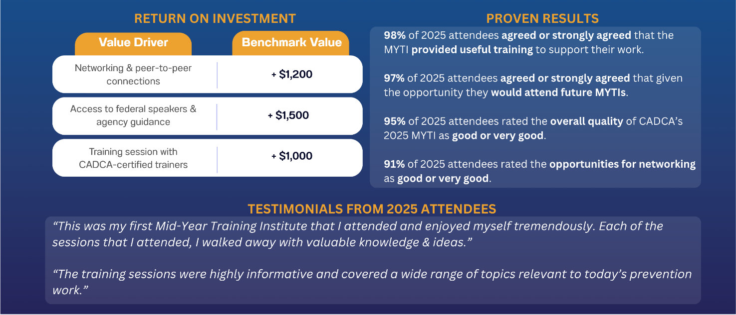
- Earn Continuing Education credits to meet professional CE requirements

I am fully committed to maximizing the value of this investment by engaging fully in sessions relevant to our work and sharing learnings with the team upon my return. I’m happy to discuss further or provide additional details about the program.

Thank you for considering this request.

Best,
[Your Name]

